**Visualization Tool For Electric Vehicle Charge And Range Analysis**

**Team ID :** NM2023TMID29037

**Team Size :** 4

**Team Leader :** MESMITHA M

**Team member :** SONY F

**Team member :** LEKHA V L

**Team member :** ADLIN VINCIBA V

**INTRODUCTION**

* 1. Overview

A brief description about your project

* 1. Purpose

The use of this project .What can be achieved

Using this.

**Problem Definition & Design Thinking**

* 1. Empathy Map

Paste the empathy map screenshot

* 1. Ideation & brainstorming map screenshot

Paste the ideation & brainstorming map screenshot

**RESULT**

Final findings (Output) of the project along with screenshots.

**ADVANTAGES & DISADVANTAGES**

List of advantages and disadvantages of the proposed solution

**APPLICATIONS**

The areas where this solution can be applied

**CONCLUSION**

Conclusion summarizing the entire work and findings.

**FUTURE SCOPE**

Enhancements that can be made in the future.

**APPENDIX**

1. Source Code

Attach the code for the solution built.

* 1. **Overview**

A vehicle that can be powered by an electric motor that draws electricity from a battery and is capable of being charged from an external source and have an electric motor instead of an internal combustion engine. The Electric Vehicle (EV) is not new, but it has been receiving significantly more attention in recent years. Advances in both EV analytics and battery technologies have led to increased automotive market share. However, this growth is not attributed to hardware alone. The modern mechatronic vehicle marries electrical storage and propulsion systems with electronic sensors, controls, and actuators, integrated closely with software, secure data transfer, and data analysis, to form a comprehensive transportation solution. Advances in all these areas have contributed to the overall rise of EV’s, but the common thread that runs through all these elements is data analytics. The new EV’s are combined Electrical storage and propulsion systems with electronic sensors, controls, and actuators, integrated closely with software, secure data transfer to form a comprehensive transportation solution.

* 1. **Purpose**

To accomplish this, we have to complete all the activities listed below,

● Define Problem / Problem Understanding

o Specify the business problem

o Business requirements

o Literature Survey

o Social or Business Impact.

● Data Collection & Extraction from Database

o Collect the dataset,

o Storing Data in DB

o Perform SQL Operations

o Connect DB with Tableau

● Data Preparation

o Prepare the Data for Visualization

● Data Visualizations

o No of Unique Visualizations

● Dashboard

o Responsive and Design of Dashboard

● Story

o No of Scenes of Story

● Performance Testing

o Amount of Data Rendered to DB ‘

o Utilization of Data Filters

o No of Calculation Fields

o No of Visualizations/ Graphs

● Web Integration

o Dashboard and Story embed with UI With Flask

● Project Demonstration & Documentation

o Record explanation Video for project end to end solution

o Project Documentation-Step by step project development procedure

**Empathy Map**

An **empathy map** is a widely-used visualization tool within the field of [UX](https://en.wikipedia.org/wiki/User_experience_design) and [HCI](https://en.wikipedia.org/wiki/Human%E2%80%93computer_interaction) practice. In relation to [empathetic design](https://en.wikipedia.org/wiki/Empathic_design), the primary purpose of an empathy map is to bridge the understanding of the end user. Within context of its application, this tool is used to build a shared understanding of the user's needs and provide context to a user-centered solution.

The traditional empathy map begins with four categories: says, thinks, does, and feels. At the center of the map, a user or persona is displayed to remind practitioners and stakeholders what type of individual this research is centered around. Each category of the empathy map represents a snapshot of the user's thoughts and feelings without any chronological order.

* **Says** category contains what the user says out loud during research or testing. Ideally, each point is written down as close to the user's original words as possible.
* **Thinks** category contains what the user is thinking. While content may overlap with the *Says* category, *Thinks* category exists to capture thoughts users may not want to share willing due to social factors, such as self-consciousness or politeness.
* **Does** category contains the user's action and behaviors. This contains what the user is physically doing and captures what actions users are taking.
* **Feels** category contains the user's emotional state in context with their experience. This typically contains information or phrases as to how they feel about the experience.

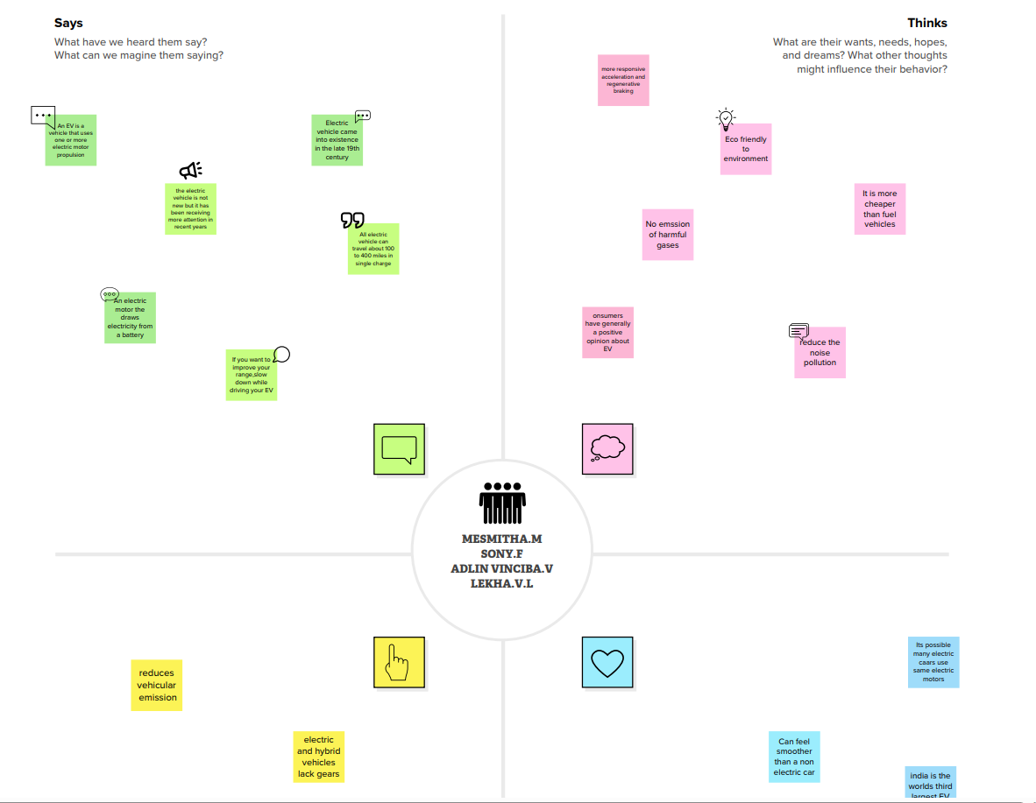

**Ideation & Brainstorming Map**

**Brainstorming** is a group [creativity technique](https://en.wikipedia.org/wiki/Creativity_technique) by which efforts are made to find a conclusion for a specific problem by gathering a list of ideas spontaneously contributed by its members.[[*citation needed*](https://en.wikipedia.org/wiki/Wikipedia:Citation_needed)]

In other words, brainstorming is a situation where a group of people meet to generate new ideas and solutions around a specific domain of interest by removing inhibitions. People are able to think more freely and they suggest as many spontaneous new ideas as possible. All the ideas are noted down without criticism and after the brainstorming session the ideas are evaluated

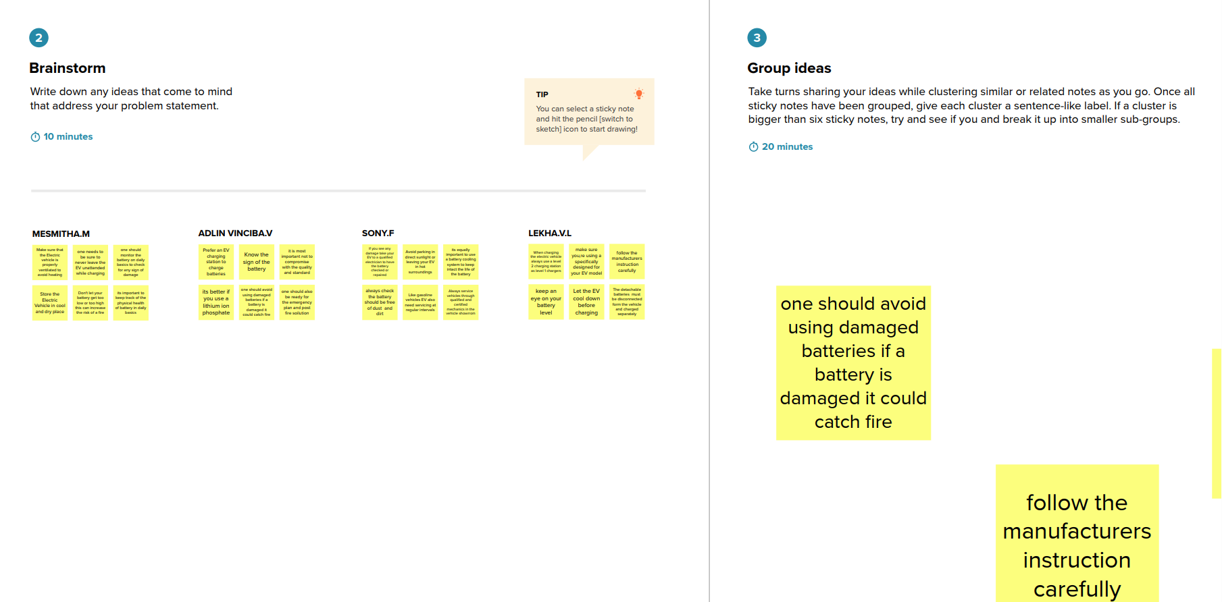

**RESULT**

**The dashboard and story of electric vehicles in India is published in tableau public.**

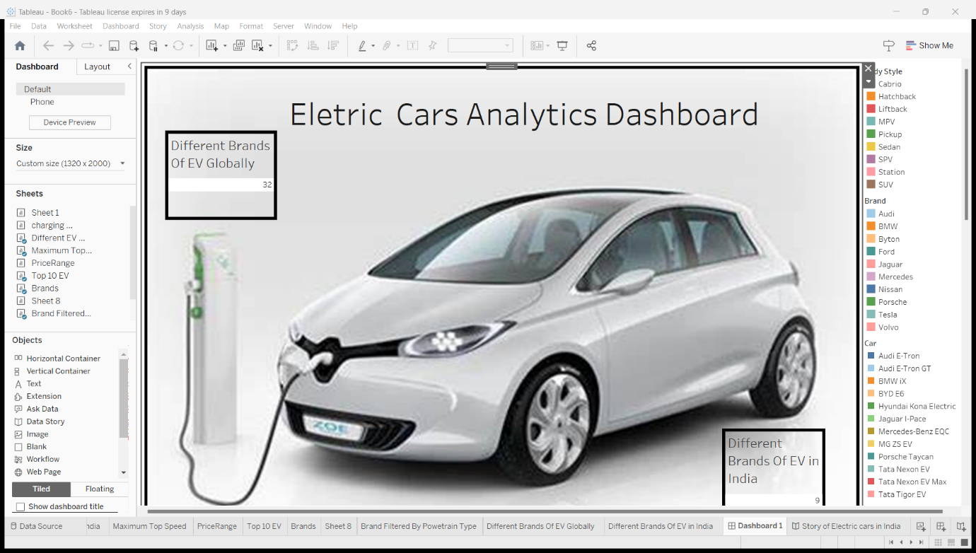

**ADVANTAGES & DISADVANTAGES**

**Advantages:**

* **No congestion charge**
* **Lower running costs**
* **Renewable electricity tariffs**
* **Better driving experience**
* **Government funding**
* **Free parking**
* **Reduced noise pollution**
* **Increased resale value**
* **Better for our planet**
* **Cheaper service and maintenance**
* **Cleaner environment**
* **EVs have more responsive acceleration and regenerative braking**

**Disadvantages:**

* **Electric cars can be expensive to buy**
* **You can’t drive as far in an electric car**
* **No enough charging points**
* **There batteries need rare metals**
* **Making electric cars create more emission**
* **They are only as green as their power sources**
* **Limited battery range**
* **Long charging times**
* **More expensive to buy**
* **Easily catches fire**

**Applications of Electric vehicles**

1. **Personal transportation: Many people use EVs as their primary mode of transportation for commuting,running errands and other daily activities. EVs can be particularly well suited for urban and suburban drivings where they can take advantage of their quick acceleration and relatively short driving range.**
2. **Public transportation:Some cities and transit agencies have started to adopt EVs for use in their public transportation systems. This include buses,shuttles,and other types of shared-ride vehicles. EVs can provide a more sustainable and cost-effective alternative to traditional fuel powered buses and other vehicles.**
3. **Commercial transportation: EVs are also used invariety of commercial applications, including delivery vehicles, utility vehicles, and fleet vehicles. Companies are increasingly adopting EVs as a way to reduce their environmental impact and operating costs.**
4. **Industrial uses: EVs are also used in industrial settings for tasks such as material handling, ground support equipment, and other specialized applications. They can a cleaner and more efficient alternative to gasoline or diesel powered vehicles in these types of environments.**

**CONCLUSION:**

The conclusion summarise the key arguments

* Top 10 Electric vehicles
* Maximum speed of an electric vehicle
* Price range
* Different brands of EV

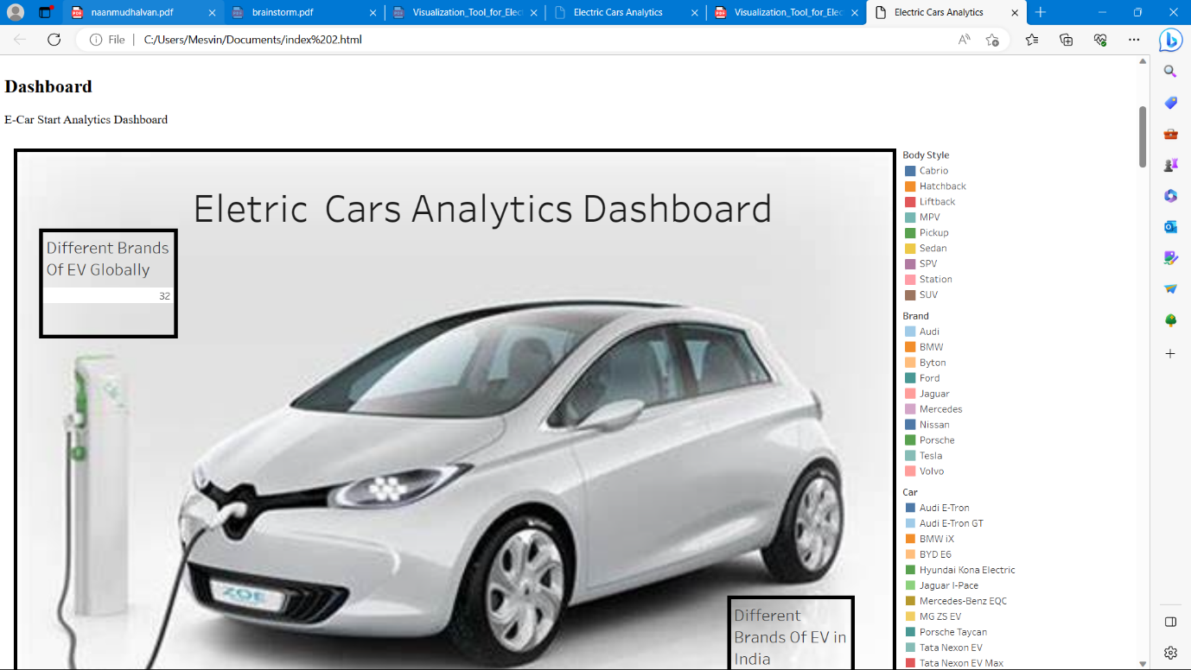

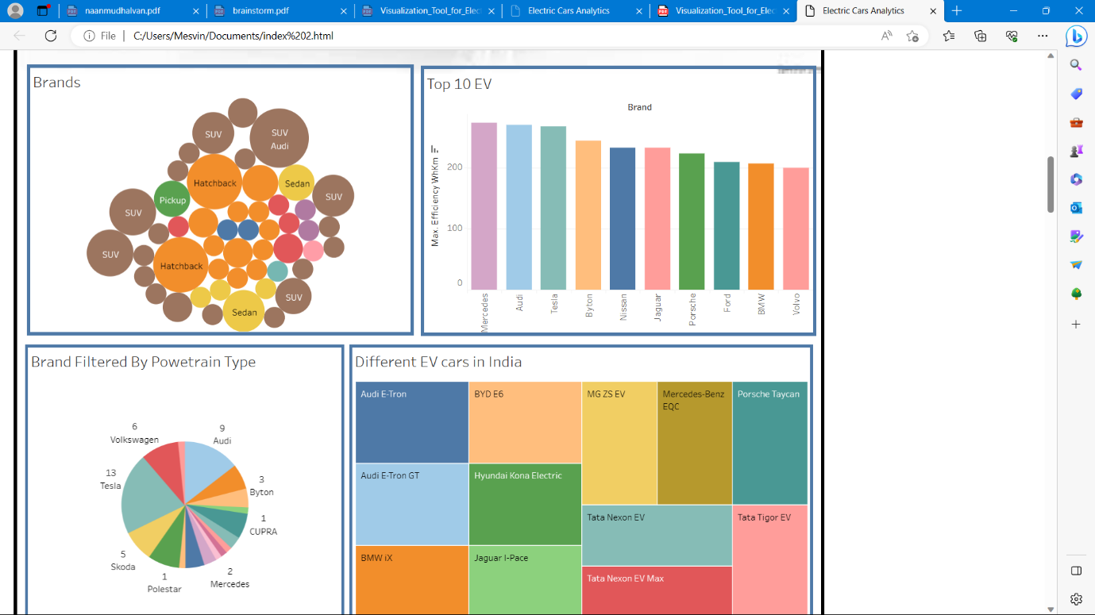

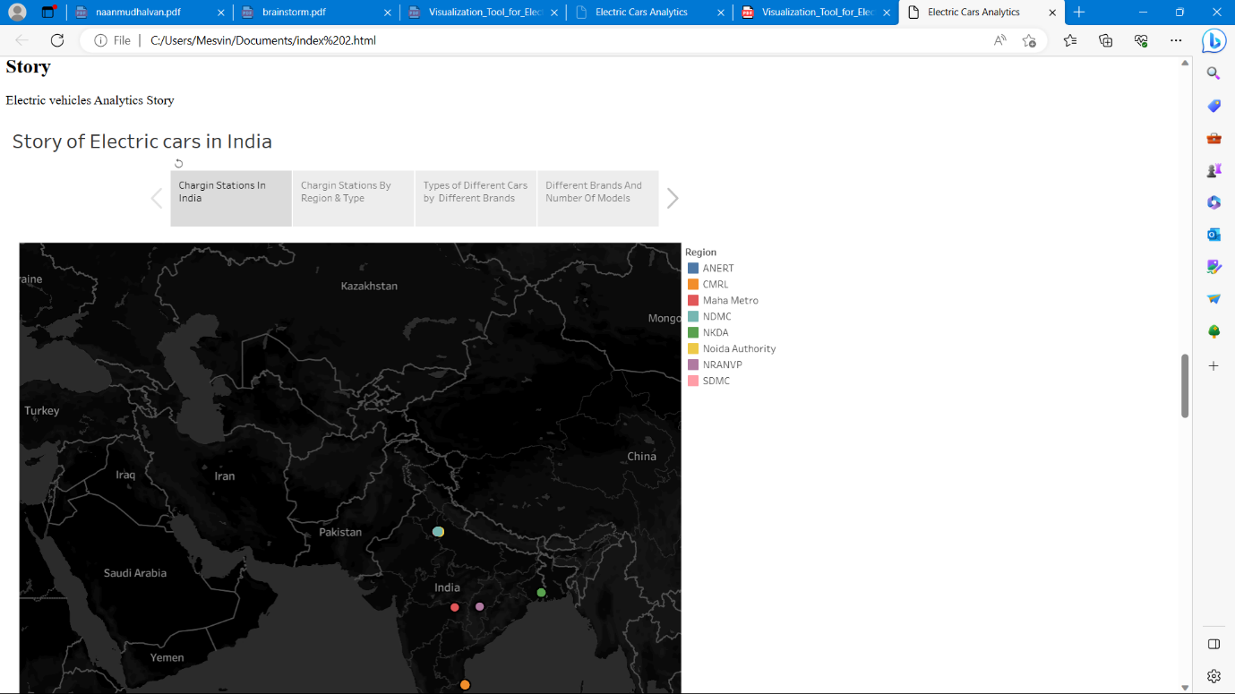

**Future scope:**

**Experts believe that the car industry will be drastically different by 2025 as a result of the shift from traditional cars to electric vehicles. According to their forecast, the electric vehicle market share will increase from 3% to 23% by 2025.**

